**Migrating Workbooks**

**Use this way only if there is no Bind Parameters (Input Parameters) for BI Publisher Report**

Open the workbook in Oracle Discoverer, using either Discoverer Plus or Discoverer Desktop.

Once opened, go to the **Tools (Tools) -> Show SQL.**

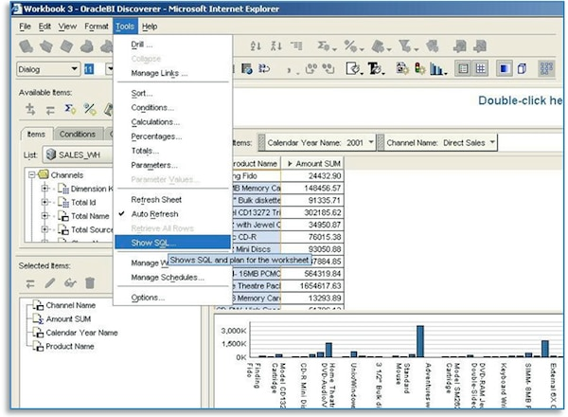

Choosing this option opens a window that displays the SQL statement that is generated by the workbook. Use the copy button in the window to copy the entire statement.

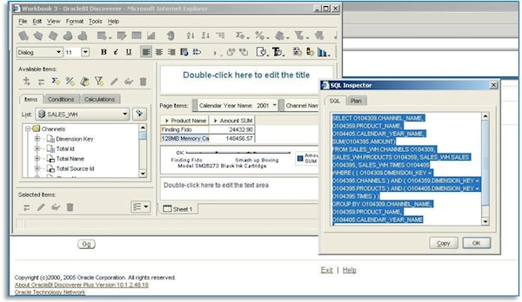

Go to OBIEE and select "Create Analysis" and then "Create Direct Database Request".

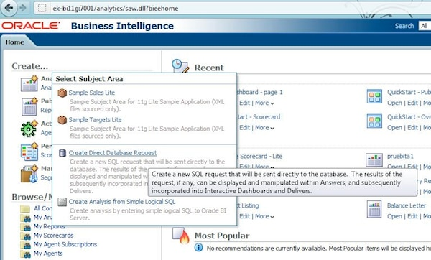

In the next window, enter the name of the Connection Pool and paste the SQL statement copied from Discoverer. Press the button **Validate SQL and retrieve columns** to select columns. (Note: the name and details of the Connection Pool are in the repository at the physical layer.)

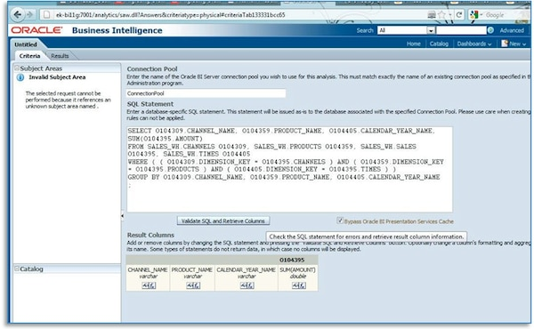

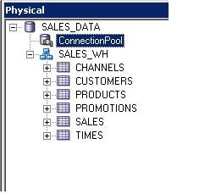

Switching to the Results tab displays the data for this query.

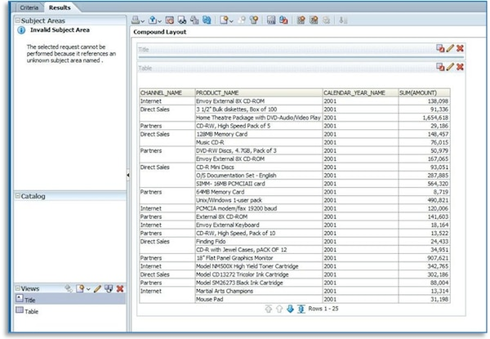

To get the results in the same format we had in Discoverer, drag the fields Channel Name and Calendar_Year_Name to the Table Prompts area.

